Go to the search for AWS Partners page

<https://partners.amazonaws.com/search/partners/?loc=United%20States>

1. Search united states, AWS Consulting partner, Premier

Gather the information highlighted below into a spreadsheet something like this



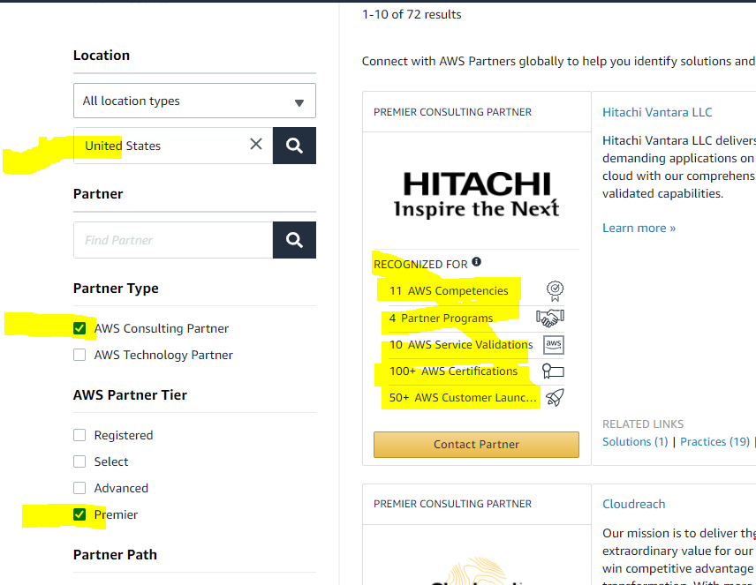

1. Next search in US, Partner Type AWS Technology Partner, Partner Tier Advanced, and collect the same information as I requested above, but ONLY for those partners who have 500+ customer launches

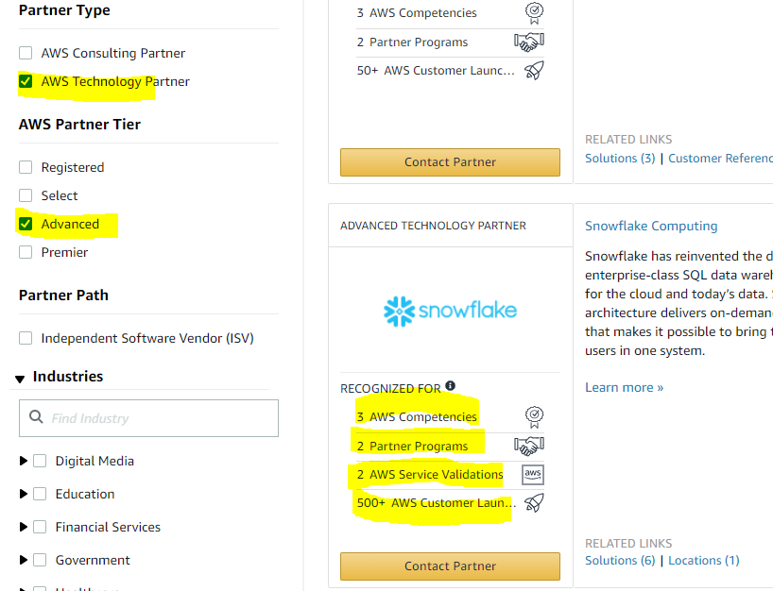

1. Next Search US, Partner Path ISV, Partner tier advanced and Premier, and again only include the ones with 500+ customer launches

